**This is the resubmission of our earlier manuscript**

**TBME-00808-2018 entitled**

***“Non-Gaussian Modeling of Surface EMG Signals Based on a Scale Mixture Model with Variance Distribution.”***

**This file also includes a response letter to the reviewers.**

October xx, 2018

**Reply to reviewers’ comments** (FURUI, A. *et al.*: Non-Gaussian Modeling of Surface EMG Signals Based on a Scale Mixture Model with Variance Distribution)

Professor Bin He

Editor-in-Chief, IEEE Transactions on Biomedical Engineering

Professor and Head, Department of Biomedical Engineering

Carnegie Mellon University

Pittsburgh, PA 15213, USA

TBME-00808-2018: Non-Gaussian Modeling of Surface EMG Signals Based on a Scale Mixture Model with Variance Distribution

Dear Professor Bin He,

The authors are grateful to you and the reviewers for your valuable suggestions and constructive comments on the submitted manuscript. We have accepted all suggestions and revised the manuscript accordingly. The resubmitted file contains our responses to the reviewers (summary of changes) and the revised manuscript with changes highlighted in yellow.

Thank you again for investing your time and effort in thoroughly reviewing the manuscript and helping us improve it.

Yours sincerely,

Akira Furui and Toshio Tsuji (corresponding authors)

4-1 Kagamiyama 1-chome, Higashi-Hiroshima-shi, Hiroshima, 739-8527 Japan

Graduate School of Engineering, Hiroshima University

Biological Systems Engineering Laboratory

Tel: +81-82-424-7677

E-mail: [akirafurui@hiroshima-u.ac.jp](mailto:akirafurui@hiroshima-u.ac.jp), tsuji@bsys.hiroshima-u.ac.jp

**Title: A Scale Mixture-based Stochastic Model of Surface   
EMG Signals with Variable Variance**

**- Authors’ Response and List of Changes -**

**Associate Editor’s Comments**

**General Comments**

The reviewers have provided positive comments on your manuscript and I concur with them that it has potential high impact in the field. Nonetheless, many clarifications are needed on the methodology, as extensively discussed by the reviewers.

Special attention should be paid in better discussing the novelty with respect to your reference [24].

The most novel contributions of the current manuscript with respect to [24] need to be highlighted and also better detailed.

**Responses**

First, we are grateful to you and the reviewers for your constructive comments. In line with the suggestions made, we have improved the relevant descriptions and added new experimental results and extra discussion to the revised manuscript.

The major changes from the previous manuscript are as follows:

1. Descriptions regarding the variance distribution estimation method have been revised to clarify the derivation procedures for updating formulas.
2. The simulation experiment has been re-conducted using a wider range of parameters.
3. Comparison with the previous model (reference [24]) has been conducted.
4. The novelty of the proposed model with respect to conventional stochastic models including [24] has been highlighted.
5. The title of the manuscript has been revised.

**Title: A Scale Mixture-based Stochastic Model of Surface   
EMG Signals with Variable Variance**

**- Authors’ Responses and List of Changes -**

**Reviewer Comments**

**Reviewer #2**

* **General Comments Rev #1**

The paper is clear and well written. The paper goes one step further than one previous paper of the same authors (reference [24]) with more material.

* **Comment Rev #1-1**

Even if some comparative results are shown with Laplacian and Gaussian distributions, a natural comparison should also be a comparison with the method of reference [24].

**Response to Rev #1-1**

Thank you very much for your valuable comments. In the revised manuscript, the previous model (reference [24]) has been added to comparison in the goodness-of-fit test. The results show that the goodness of fit of the previous model is significantly lower than that of the proposed method, and fell between those of the Gaussian and Laplacian models. The revised manuscript also includes discussion of novelty with respect to [24].

**Modification Rev #1-1**

**III. Experiments**

**B. EMG Analysis**

**Page 4, column 2, line 17 from top**

“For comparison, the index was also calculated by fitting the data to a Gaussian distribution model [14], a Laplacian distribution model [18], and the previous model proposed by Hayashi *et al.* [24].”

**Page 4, column 2, line 23 from top**

“In the previous model, variance distribution parameters were estimated based on an approximation method using rectified/smoothed EMG signals. This method requires a prior shape parameter ${\hat{α}}^{pre}$, which is calculated from pre-measured EMG signals $X^{pre}$ and is fixed in advance for each participant. Accordingly, 10,000 samples were randomly sampled from the measured EMG signals of all trials for the target force of 80% MVC, and were handled as $X^{pre}$.”

**IV. Results**

**B. EMG Analysis**

**Page 5, column 1, line 9 from top**

“Fitted distributions with the scale mixture model, the previous model, the Laplacian model, and the Gaussian model are also shown as solid lines, dashed lines, dotted lines, and dash-dotted lines, respectively.”

**Page 5, column 1, line 8 from bottom**

“For FDI muscle, there were significant differences between the scale mixture model and both the previous model and the Gaussian model for all target forces. A significant difference between the scale mixture model and the Laplacian model was observed only for a target force of 5% MVC.”

**Page 6, Fig. 7**

**Before**



**After**



Fig. 7. Examples of measured EMG signals and corresponding density histograms recorded from BB muscle. (a) Measured EMG signals recorded from BB muscle for 5, 30, 50, and 80% MVC. (b) Density histogram of measured EMG signals recorded from BB muscle and fitted distributions based on the proposed scale mixture model, our previous model, the Laplacian model, and the Gaussian model for 5, 30, 50, and 80% MVC.

**Page 6, Fig. 8**

**Before**



**After**



Fig. 8. Results of goodness-of-fit test for each muscle. (a) FDI muscle. (b) BB muscle. Error bars represent 95% confidence intervals for all participants. The statistical test results based on the Wilcoxon signed rank test with the Holm-Bonferroni adjustment are also shown (*: *p* < 0.05).

**V. Discussion**

**Page 7, column 2, line 10 from bottom**

“The AD statistics for the scale mixture model are significantly lower than those of the previous model proposed by Hayashi *et al.* [24] and the Gaussian model for all target forces in both muscles.”

**Page 8, column 1, line 7 from top**

“The goodness of fit of the previous model fell between those of the Gaussian model and the Laplacian model. Although the previous model also has a heavier tail than the Gaussian model, its tail weight is constant because the shape parameter $α$ controlling non-Gaussianity is fixed in advance. Consequently, the previous model showed worse fitting results than the proposed model. This suggests that accurate evaluation of changes in EMG signal distribution shape requires estimation of both $α$ and $β$, which is achievable with the proposed model. The previous model based on approximate estimation using rectified/smoothed EMG signals is therefore effective only when the actual shape parameter is known.”

**Page 8, column 1, line 3 from bottom**

“This intermuscular difference in the variance distribution parameter $α$ is a novel finding, as experiments in previous studies were performed only for single muscles [24], [25].”

**VI. Conclusion**

**Page 8, column 2, line 7 from bottom**

“This helps to clarify changes in the non-Gaussianity of EMG signals associated with muscle activity.”

* **Comment Rev #1-2**

The main novelty in the methods section relies on the use of the EM algorithm. This part should be more detailed. Where does the formula of eq. (6) come from? An appendix or a literature reference (maybe [25]) may be added.

**Response to Rev #1-2**

Thank you for the valuable suggestion. In the revised manuscript, Section II-B (Variance Distribution Estimation Based on Marginal Maximum Likelihood) has been revised. In particular, the derivation procedures for updating formulas based on the EM algorithm have been presented in more detail. The notations of some variables have been changed.

**Modification Rev #1-2**

**II. Scale Mixture Model of Surface EMG Signals**

**B. Variance Distribution Estimation Based on Marginal Maximum Likelihood**

**Page 2, column 2, line 5 from bottom**

“This is because direct optimization of marginal likelihood is generally problematic [26].”

**Page 3, column 1, line 1 from top**

“Equation (3) is transformed via the introduction of the new parameterization $ν=2α$ and $s=β/α$, with the latent variable defined as $τ_{n}={σ_{n}}^{2}α/β$. Marginal distribution can then be expressed as

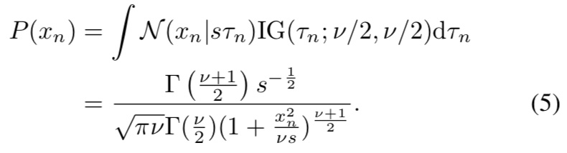

This expression is equivalent to Student's *t*-distribution with a mean of zero, in which $ν$ is the degree of freedom and $s$ is the scale parameter of the *t*-distribution [26]. Here, the posterior distribution of the latent variable is given by



The parameters [$ν$, $s$] are estimated as outlined below based on the EM algorithm.

1. Initialize $ν$ and $s$ with the selection of arbitrary starting values.
2. E-step. Calculate the expectation of the complete-data log likelihood. This expectation, denoted as $Q(ν, s)$, is given by  
     
   where $ψ(∙)$ is a digamma function and $w_{n}$ is the expectation of the latent variable as calculated from (6).  
   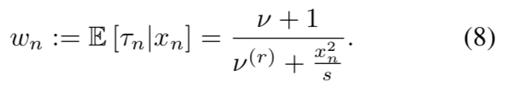
3. M-step. Update the parameters by maximizing $Q(ν, s)$. The new scale parameter is determined as  
     
   There is no closed-form expression for the degree of freedom. Hence, it is updated by finding $ν$, where the complete-data log likelihood is maximized numerically based on a line search.  
   
4. Evaluate the log-marginal likelihood  
   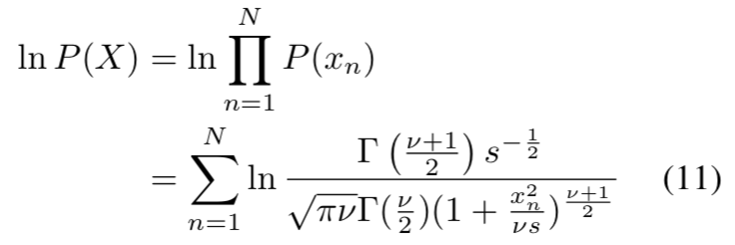  
   and determine whether the convergence of the estimation is reached when the relative change in the log-marginal likelihood between iterations falls below the predetermined threshold $ε$. If the convergence criterion is not satisfied, return to step (ii).”

* **Comment Rev #1-3**

Which is the convergence or stopping criterion the authors use for the algorithm?

**Response to Rev #1-3**

In the proposed estimation method, algorithm convergence is judged to occur when the relative change in the log-marginal likelihood between iterations falls below a predetermined threshold.

As stated in Response to Rev #1-2, the convergence criterion is outlined in Section II of the revised manuscript. Details of convergence threshold setting have also been included in the Experiments section.

**Modification Rev #1-3**

**II. Scale Mixture Model of Surface EMG Signals**

**B. Variance Distribution Estimation Based on Marginal Maximum Likelihood**

**Page 3, column 1, line 3 from bottom**

“(iv) Evaluate the log-marginal likelihood



and determine whether the convergence of the estimation is reached when the relative change in the log-marginal likelihood between iterations falls below the predetermined threshold $ε$. If the convergence criterion is not satisfied, return to step (ii).”

**III. Experiments**

**A. Simulation**

**Page 3, column 2, line 16 from bottom**

“…, and the convergence threshold was set to $ε={10}^{-7}$.”

**B. EMG Analysis**

**Page 4, column 2, line 3 from top**

“The settings of the initial values and the convergence threshold in parameter estimation were as per the simulation experiment.”

* **Comment Rev #1-4**

What about local minima possibilities? What is the motivation behind the range (0,10) for the initialization step of the dof and scale parameters?

**Response to Rev #1-4**

Thank you for the valuable comments. First, convergence in the proposed parameter estimation method is theoretically guaranteed because it is an EM algorithm-based optimization approach. As you mentioned, however, a local maximum may exist. This problem may also be related to the setting of parameter initialization. Accordingly, parameter estimation was conducted in the simulation experiment using several initial values randomly selected from the wider range of (0, 50). With these conditions, the estimation results converged to the same values for all initial values; hence, convergence to a global maximum appears to have occurred.

For reference, examples of parameter convergence with several initial values are outlined below.

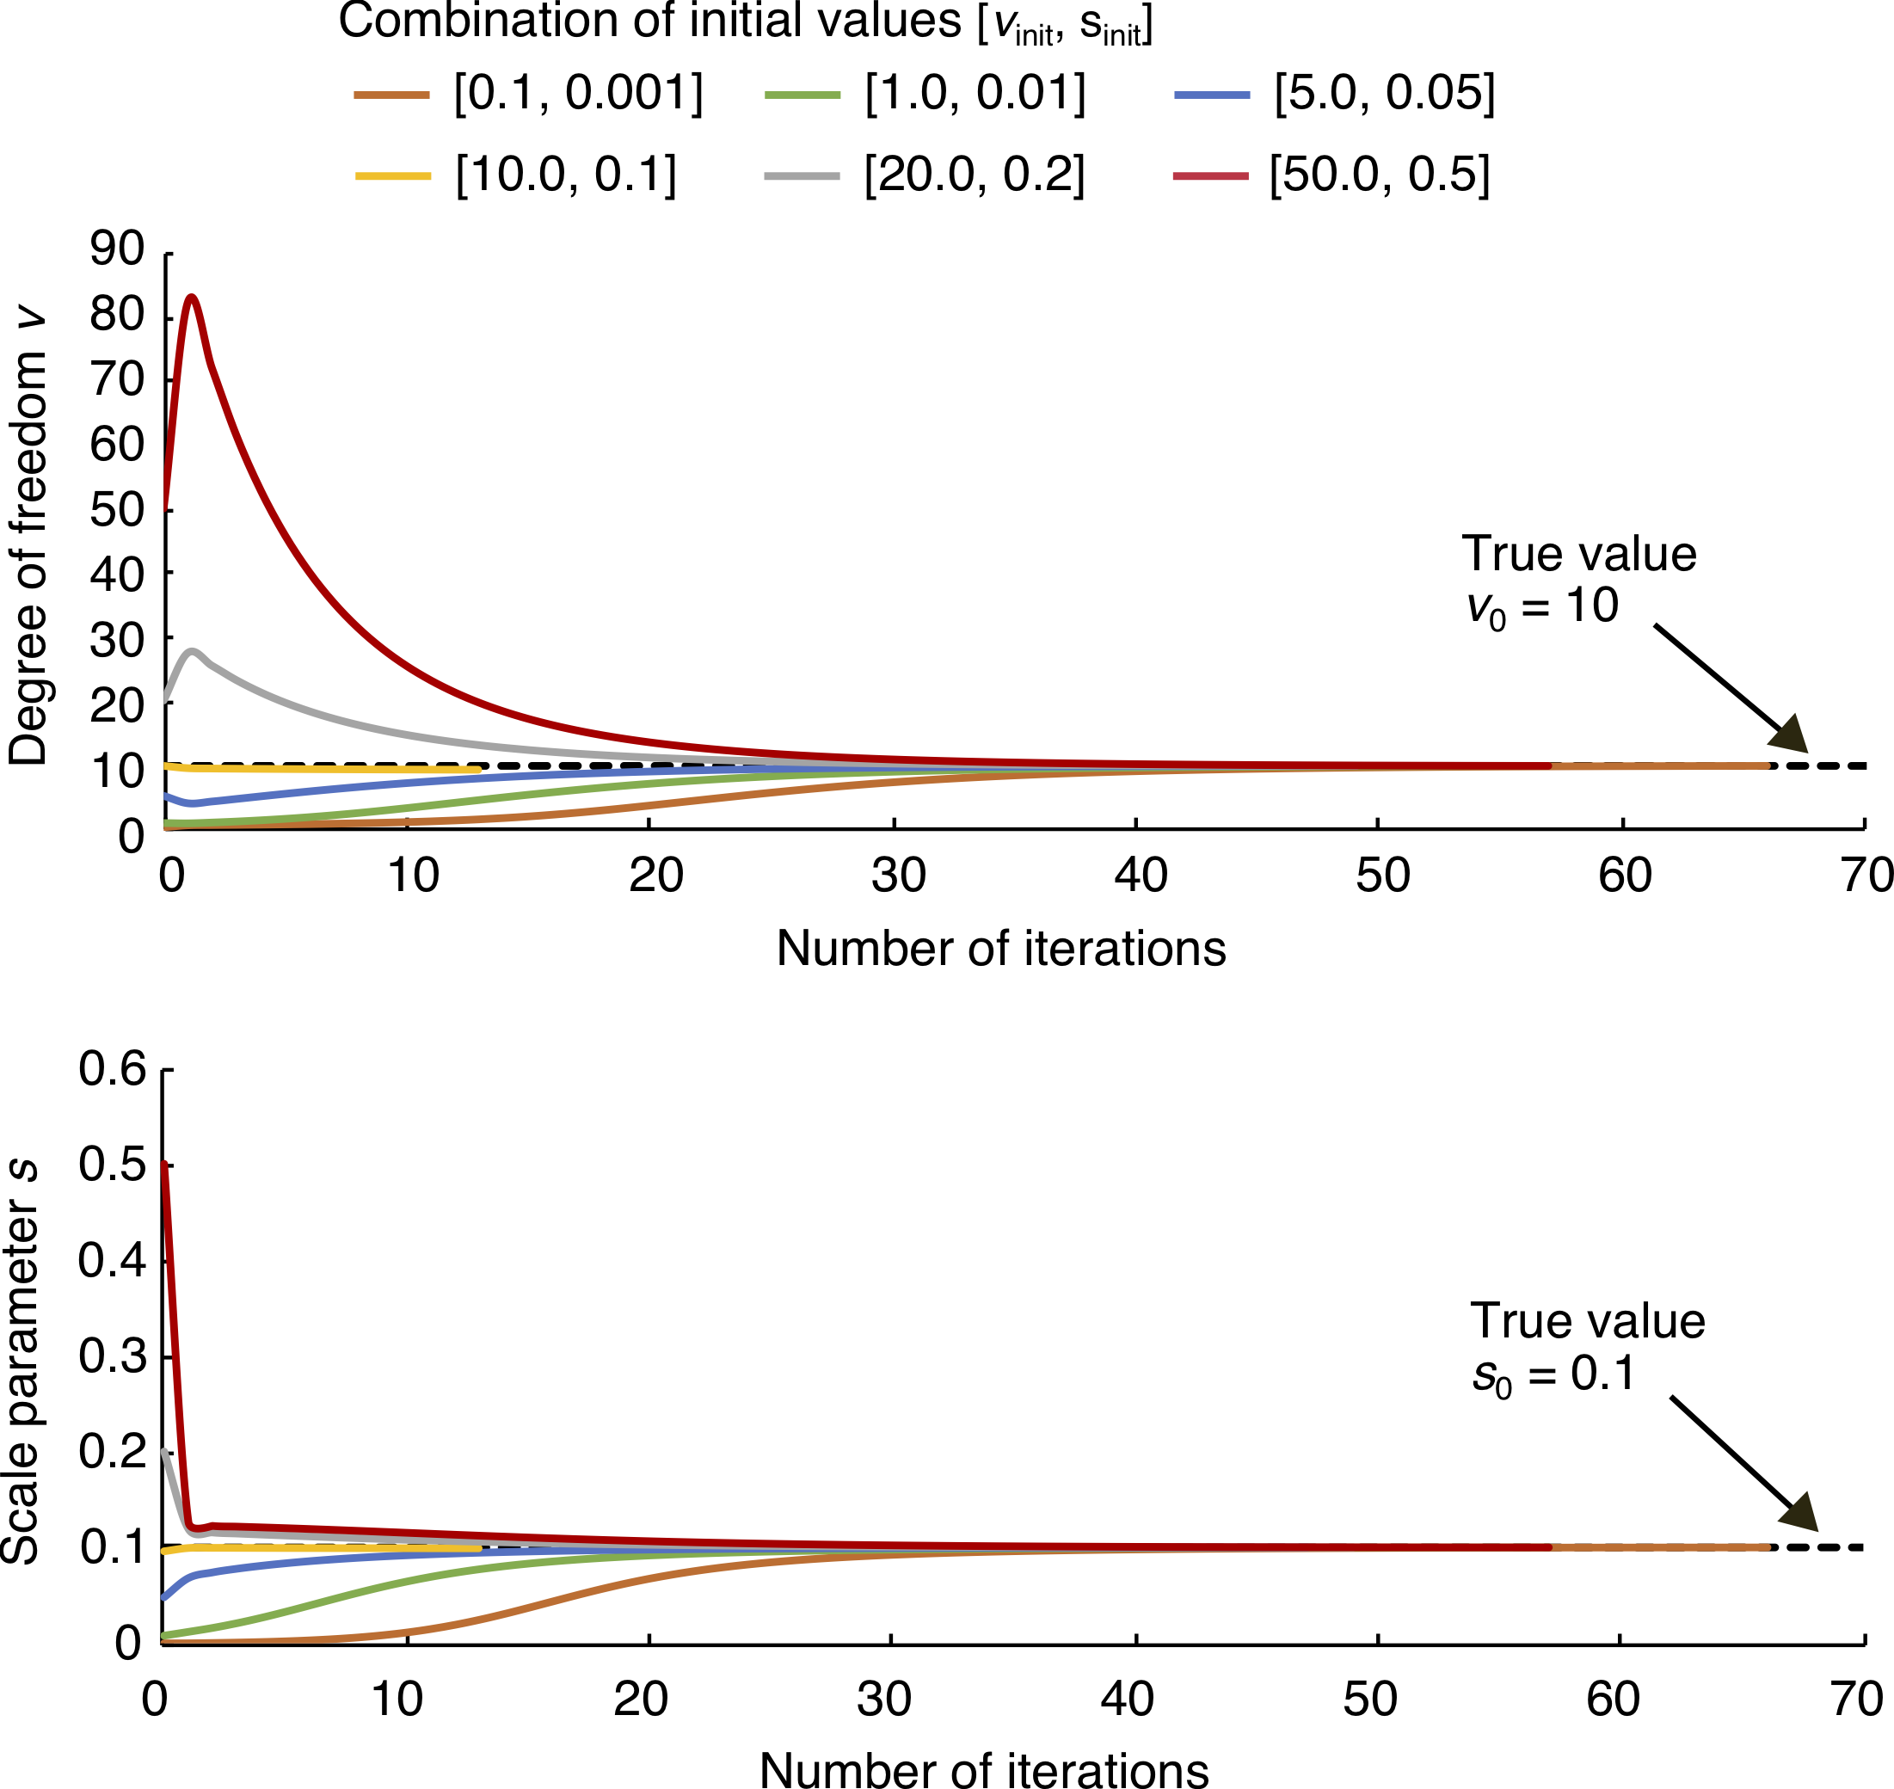

Fig. A1: Examples of estimation results with several initial values

Fig. A1 shows examples of estimation results for artificial EMG signals with combinations of several initial values of the degrees of freedom $ν_{init}$ and the scale parameter $s_{init}$. These signals were produced with $L=5$ s and true values of [$α_{0}, β_{0}$] = [5.0, 0.05] (i.e., Student’s *t*-distribution parameters [$ν_{0}, s_{0}$] = [10.0, 0.1]).

In the figure, the estimations converge to the same true value for all initial values. This indicates that estimation accuracy does not depend on the setting of initial values, although convergence is faster when the initial value is closer to the true value.

The revised manuscript includes a description of convergence with the proposed estimation method. The above results regarding convergence from several initial values have also been added.

**Modification Rev #1-4**

**II. Scale Mixture Model of Surface EMG Signals**

**B. Variance Distribution Estimation Based on Marginal Maximum Likelihood**

**Page 3, column 2, line 6 from top**

“As each cycle of the EM algorithm will increase the log-marginal likelihood monotonically [26], the convergence of parameter estimation is guaranteed.”

**III. Experiments**

**A. Simulation**

**Page 3, column 2, line 18 from bottom**

“The initial parameter values in estimation were set using uniform random numbers in the range of (0, 50), and…”

**IV. Results**

**A. Simulation**

**Page 4, column 2, line 16 from bottom**

“For each condition of true values, variance distribution parameters were estimated using a number of initial values selected on the basis of uniform random numbers. In the results, the estimations converged to the same values.”

**V. Discussion**

**Page 6, column 2, line 15 from top**

“In the simulation experiment, the estimation results for $α$ and $β$ converged to the same values starting from several different initial values. Thus, convergence to a global maximum appears to have occurred. This indicates that the proposed parameter estimation method is robust regardless of the setting of initial values.”

* **Comment Rev #1-5**

To my opinion, the title of the paper is not so easy to understand at first glance and should be made more explicit if possible.

**Response to Rev #1-5**

The title has been changed to improve clarity. Thank you for the valuable suggestion.

**Modification Rev #1-5**

**Title**

“Non-Gaussian Modeling of Surface EMG Signals Based on a Scale Mixture Model with Variance Distribution”

--> “A Scale Mixture-based Stochastic Model of Surface EMG Signals with Variable Variance”

* **Comment Rev #1-6**

Some reformulations of the last paragraph before section III.B are needed.

**Response to Rev #1-6**

Thank you very much for the valuable comment. The paragraph has been revised.

**Modification Rev #1-6**

**III. Experiments**

**A. Simulation**

**Page 3, column 2, line 23 from bottom**

“… with respect to variations in the true values $α_{0}$ and $β_{0}$. The average absolute percentage errors were also calculated for each $α_{0}$ and $β_{0}$ with a fixed value of $L=5$ s.”

--> “… with respect to variations in the true values $α_{0}$ and $β_{0}$, the average absolute percentage errors were also calculated for each value of $α_{0}$ and $β_{0}$ with a fixed value of $L=5$ s.”

* **Comment Rev #1-7**

Section III.B "subsequent trials were performed if the difference in the peak force of the two MVCs was less than 5%": is this correct?

**Response to Rev #1-7**

Yes, this is correct. The phrasing has been improved in the revised manuscript to avoid confusion. Thank you for the valuable suggestion.

**Modification Rev #1-7**

**III. Experiments**

**B. EMG Analysis**

**Page 4, column 1, line 18 from bottom**

“First, each participant performed at least two maximum voluntary contraction (MVC) trials. The trials were repeated until the peak forces of two MVCs were within 5% of each other.”

* **Comment Rev #1-8**

The alpha parameter was chosen in the range 2.5 to 10 and the beta parameter in the range 0.01 to 0.2 whereas the values the real data case are normalized in order to deal with intersubject differences. Because of normalisation, it is thus difficult to make the results in the simulated case useful for the experimental case and it is also not possible to know whether the ranges chosen in the simulated case can be suited for experimental cases.

**Response to Rev #1-8**

Thank you very much for the valuable comments. The manuscript was indeed lacking in discussion of validity between the simulation results with artificial data and the experimental results with real data. Accordingly, experimental distributions of raw variance distribution parameters estimated from measured EMG signals have been calculated, and the simulation experiment has been re-conducted using a wider range of true values corresponding to the range of the raw parameters. The results showed estimation accuracy similar to that reported in the earlier manuscript. This suggests that variance distribution can also be estimated with real EMG signals at an accuracy of about 5–10% as verified by the simulation experiment.

The revised manuscript includes results for the experimental distribution of raw variance distribution parameters and discusses the above points.

**Modification Rev #1-8**

**III. Experiments**

**A. Simulation**

**Page 3, column 2, line 25 from bottom**

“The average absolute percentage errors were calculated by changing the true values 400 times ($α_{0}=0.5, 1.0, 1,5, ⋯, 10.0, β_{0}=0.05, 0.10, 0.15, ⋯, 1.00$).”

**IV. A. Simulation**

**Page 5, Fig. 4**

**Before**



**After**



**Page 5, Fig. 5**

**Before**



**After**



**IV. Results**

**B. EMG Analysis**

**Page 5, column 1, line 1 from top**

“Fig. 6 shows the experimental distributions of $α$ and $β$ as estimated from measured EMG signals for FDI and BB muscle. These were calculated using kernel density estimation [28] with a Gaussian kernel. In this figure, $α$ and $β$ are below 4.73 and 0.96, respectively.”

**Page 5, Fig. 6**

**Added**



Fig. 6. Experimental distributions of variance distribution parameters estimated from measured EMG signals for FDI and BB muscle. (a) Shape parameter $α$. (b) Scale parameter $β$. Distributions are calculated using kernel density estimation.

**V. Discussion**

**Page 7, column 2, line 9 from top**

“In the EMG analysis experiment, the variance distribution parameters estimated from the measured EMG signals were within the ranges of the true values used in the simulation experiment (Fig. 6). This result suggests that variance distribution can also be estimated with real EMG signals at an accuracy of approximately 5–10% as verified by the simulation experiment.”

Finally, the authors appreciate the reviewer spending precious time on this review, which has led to a significant improvement in the presentation and quality of the paper. Thank you again for the review and constructive comments.

Sincerely,

Akira Furui and Toshio Tsuji

**Title: A Scale Mixture-based Stochastic Model of Surface   
EMG Signals with Variable Variance**

**- Authors’ Response and List of Changes -**

**Reviewer Comments**

**Reviewer #3**

* **General comments**

The manuscript is about the development and testing of a scale mixture distribution-based stochastic EMG model. The manuscript is well written and organized.

* **Comment Rev #2-1**

The advantages with respect to other existing models and the impact of this work should be better quantified and discussed. For example, authors should clarify what is the impact of the better performances of the fitted distribution obtained using scale mixture with respect to the performances obtained with Laplacian density and Gaussian density shown in Figure 6. On the basis of the AD statistics, authors state that “the scale mixture model enables better fitting to real EMG signals than conventional stochastic EMG models”. Even if this is a statistical result, authors should discuss the real impact of the shown differences (mainly between Laplacian and scale-mixture model).

**Response to Rev #2-1**

Thank you very much for the valuable comments. Related works previously reported that the probability distribution of EMG signals varied between a Gaussian distribution and a Laplacian distribution depending on muscle force. However, it was difficult to identify the switching point of these distributions. By contrast, the proposed scale mixture model can be used to describe changes in the non-Gaussianity of EMG signals associated with muscle activity within the unified scheme. This is a major distinctive feature of the proposed model compared with other models.

In the revised manuscript, the above points have been clarified in the Discussion section. Details of potential applications brought by the superior performance of the model have also been included.

**Modification Rev #2-1**

**V. Discussion**

**Page 8, column 1, line 20 from top**

“Based on the above, it can be concluded that the scale mixture model enables better fitting to real EMG signals than the previous model [24] and other conventional stochastic EMG models. In previous studies reporting that the probability distribution of EMG signals falls between a Gaussian and a Laplacian distribution [18], [21], it was difficult to identify the switching point of these distributions because the non-Gaussianity of such signals continuously varies with muscle force. By contrast, the proposed scale mixture model enables description of changes in the non-Gaussianity of EMG signals associated with muscle activity within the unified scheme. Further, accurate modeling of the stochastic properties of EMG signals is important in extracting the features of such signals and quantitatively evaluating neuromuscular activity. Recent studies have suggested that the non-Gaussianity of EMG signals serves as a potentially important index for EMG pattern classification [29], muscular-activity detection [30], and evaluation of neuromuscular disease [31]. Accordingly, higher performance may be realized in application fields such as prosthesis control if novel EMG processing techniques can be developed using the scale mixture model.”

**VI. Conclusion**

**Page 8, column 2, line 7 from bottom**

“This helps to clarify changes in the non-Gaussianity of EMG signals associated with muscle activity.”

Finally, the authors appreciate the reviewer spending precious time on this review, which has led to a significant improvement in the presentation and quality of the paper. Thank you again for the review and constructive comments.

Sincerely,

Akira Furui and Toshio Tsuji